**TOPIC OF SURVEY: DO I.U.P STUDENTS PREFER ON-CAMPUS OR OFF-CAMPUS HOUSING**

**DESCRIPTION OF SURVEY:**

This survey is undertaken to find out if students in general at I.U.P prefer living on campus or off campus. This helps us to understand if the students feel secure on campus and to get to know their opinion about the on-campus facilities, the diversity of cultures on campus, if living on campus is worth their money, and if they have good access to the numerous on campus resources, such as the faculty, library, academic advisors, computer labs, dining halls, and healthcare. It also helps us to analyze the level of responsibility they have on campus and off campus and their opinion on sharing option (rooms and washrooms).

**OBJECTIVES OF THE SURVEY:**

1. To know the reason why freshmen, move out of campus after residing for more than a year on campus.
2. To understand whether students off campus feel drawn away from having a full collegiate experience or do they have the same social life as the students on campus.
3. To analyze the students off campus, have less expenses as compared to the students on campus
4. To determine students off campus, have more sense of opportunity to get a deeper taste of independence and adulthood by running their own household
5. To examine if students off campus are notified and updated about all the activities on campus, and vice versa.

Questionnaire link: <https://iup.co1.qualtrics.com/jfe/form/SV_6AkZKKqt8Cr9jOl>

**CROSS TABULATION AND ANALYSIS**

1. To know the reason why freshmen, move out of campus after residing for more than a year on campus.

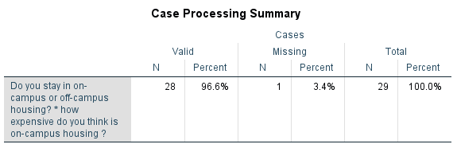

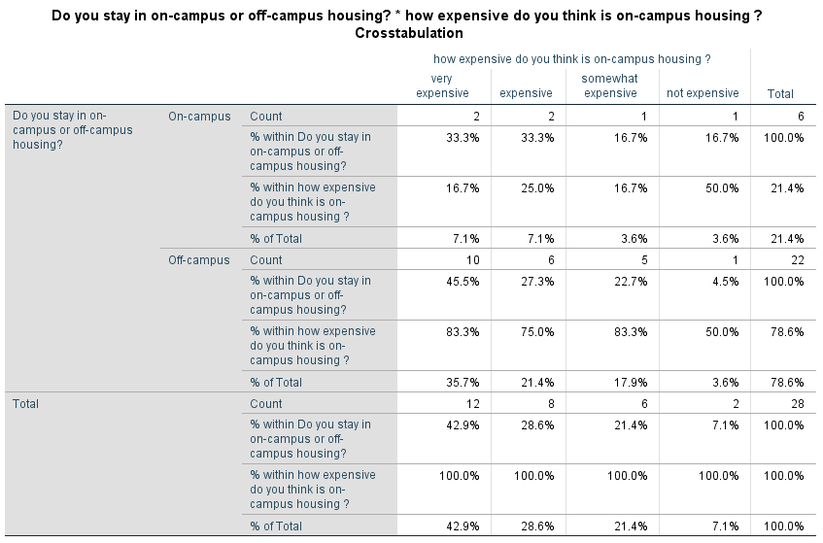

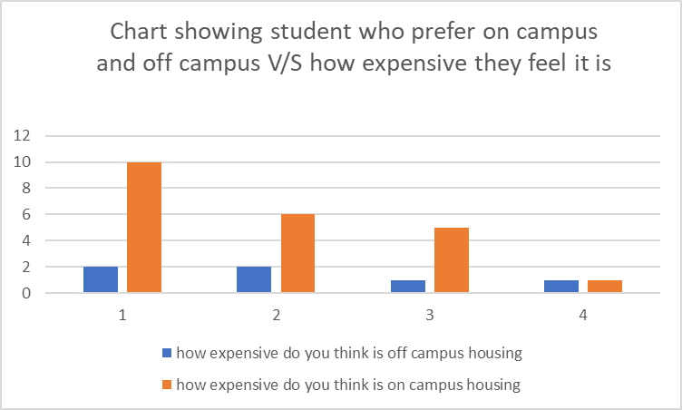

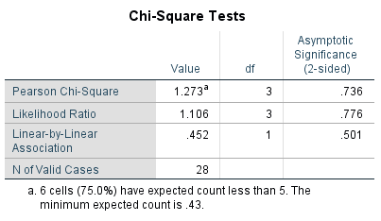

**Interpretation**: by looking at the above data, about 83% of on campus students find it expensive by staying there

**Recommendations**: As on campus housing is expensive many freshmen who stay on campus move out after a year of staying on campus.

1. To understand whether students off campus feel drawn away from having a full collegiate experience or do they have the same social life as the students on campus.

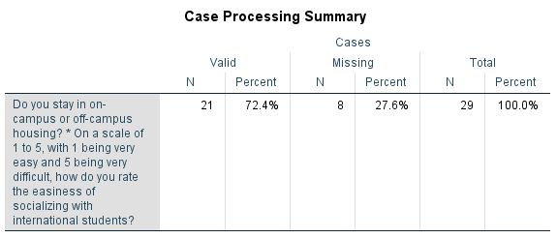

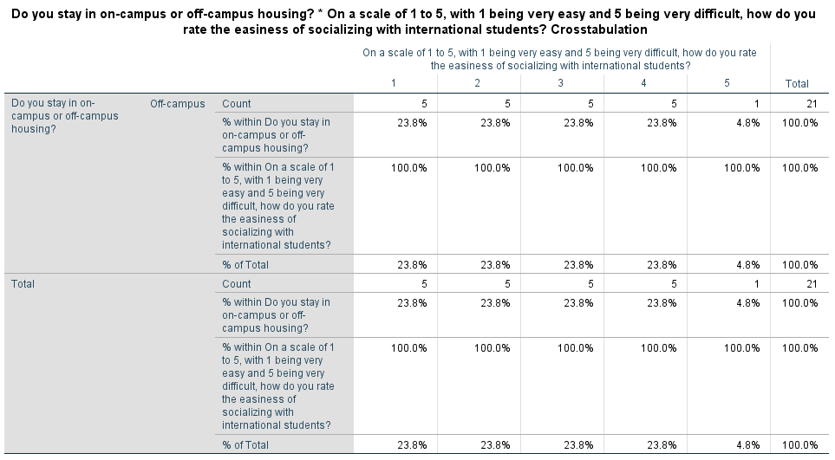

**Interpretation**: More than 52% students off campus find that it is difficult for them to socialize with the international students on campus.

**Recommendation**: As it more difficult for off campus students to socialize with the on campus international students, we suggest that they could host cultural activities and form communities on campus so that they would be able to interact and socialize with all the students on campus.

1. To analyze the students off campus, have less expenses as compared to the students on campus







**Interpretation**: According to the data collected, the students staying on campus have more expenses compared to the students living off campus, as about 75% of students find it more expensive.

**Recommendation**: the students living on campus have more expenses, it is because of their rent and the meal plans they have to subscribe for, as they do not have resources for cooking on campus. So, we recommend students to stay off campus to reduce their financial expenses.

1. To examine if students off campus are notified and updated about all the activities on campus, and vice versa.

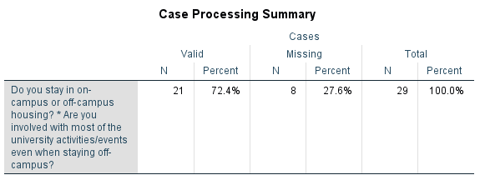

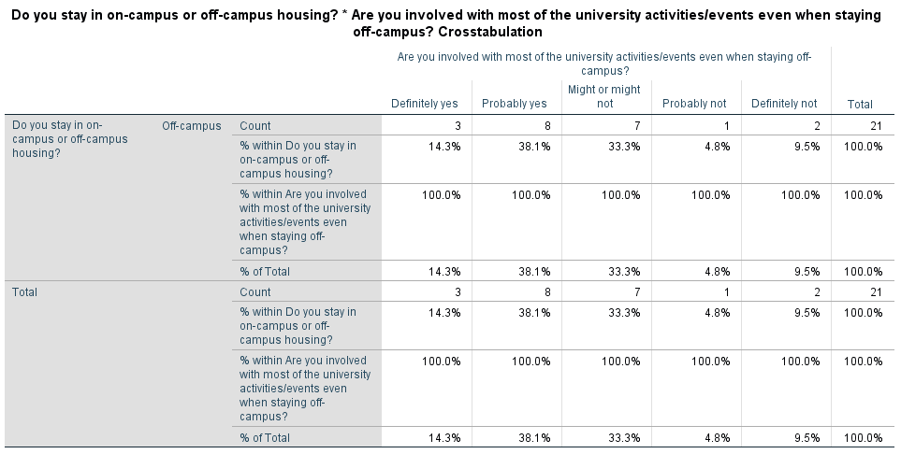

**Interpretation**: As per the above given table, about 52.4% of the students staying off campus are aware and involved with all the activities on campus and about 33% of the students feel withdrawn from the events or activities happening on campus.

**Recommendation**: We recommend that by joining the communities off campus students get notified about all the events and activities happening on campus.

1. To determine level of safety with respect to on campus and off campus housing

**On-campus Housing**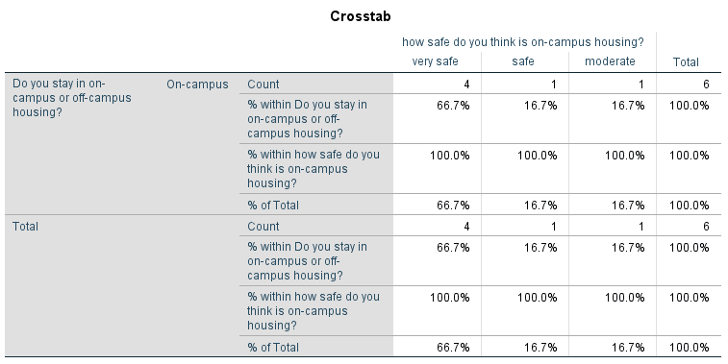

**Interpretation**: Based on the given data about 83.4% of the students staying on campus feel more secure than the students living off campus, as there is more security on campus than off campus.

**Off-campus Housing**

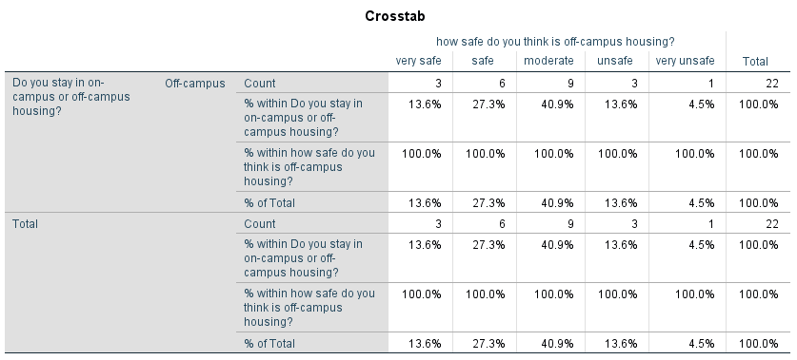

**Analysis**: Based on the given data about 41%of the students staying off campus feel less secure than the students living on campus, as there is more security on campus than off campus.

**Recommendation**: As the students living off campus feel more unsafe, we would suggest that they take the effort to find a place which would be comparatively safe for them to stay, by interacting with the neighbors and getting to know the neighborhood better before they stay there, or live on campus.

**SUMMARY OF FINDINGS:**

* by looking at the above data, about 83% of on campus students find it expensive by staying there.
* More than 52% students off campus find that it is difficult for them to socialize with the international students on campus.
* According to the data collected, the students staying on campus have more expenses compared to the students living off campus, as about 75% of students find it more expensive.
* As per the above given table, about 52.4% of the students staying off campus are aware and involved with all the activities on campus and about 33% of the students feel withdrawn from the events or activities happening on campus.
* Based on the given data about 83.4% of the students staying on campus feel more secure than the students living off campus, as there is more security on campus than off campus.

**RECOMMENDATIONS**

* As on campus housing is expensive many freshmen who stay on campus move out after a year of staying on campus.
* As it more difficult for off campus students to socialize with the on campus international students, we suggest that they could host cultural activities and form communities on campus so that they would be able to interact and socialize with all the students on campus.
* the students living on campus have more expenses, it is because of their rent and the meal plans they have to subscribe for, as they do not have resources for cooking on campus. So we recommend students to stay off campus to reduce their financial expenses.
* We recommend that by joining the communities off campus students get notified about all the events and activities happening on campus.
* As the students living off campus feel more unsafe, we would suggest that they take the effort to find a place which would be comparatively safe for them to stay, by interacting with the neighbors and getting to know the neighborhood better before they stay there, or live on campus.